Observation Sources
Observations can be loaded into VStar from a variety of sources. Out of the box, observations can be loaded from the AAVSO International Database (AID) or files conforming to one of two formats (described in the Load from File section).

Observations from other sources (e.g. other AAVSO sources, Kepler, SuperWASP, ASAS) can be loaded via plug-ins found in the AAVSO Plug-in Library (http://www.aavso.org/vstar-plugin-library).

Load from AID
To load a set of observations from the AID, ensure you are connected to the Internet, then select New Star from AAVSO Database... from the File menu or click the button at the left of the toolbar.
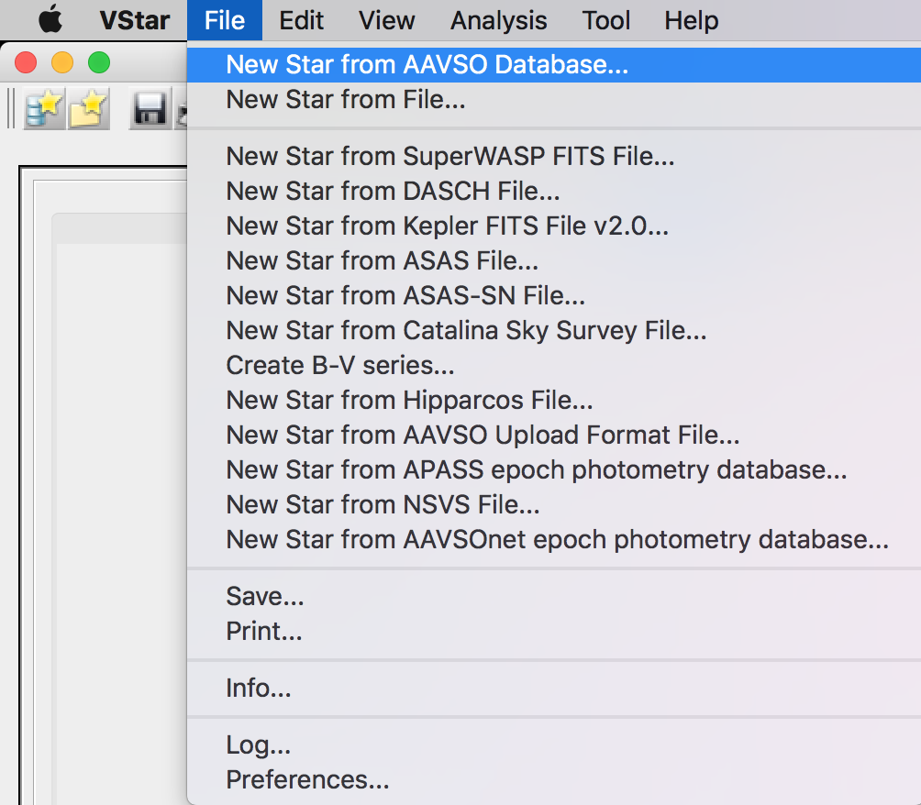
The following dialog will appear:

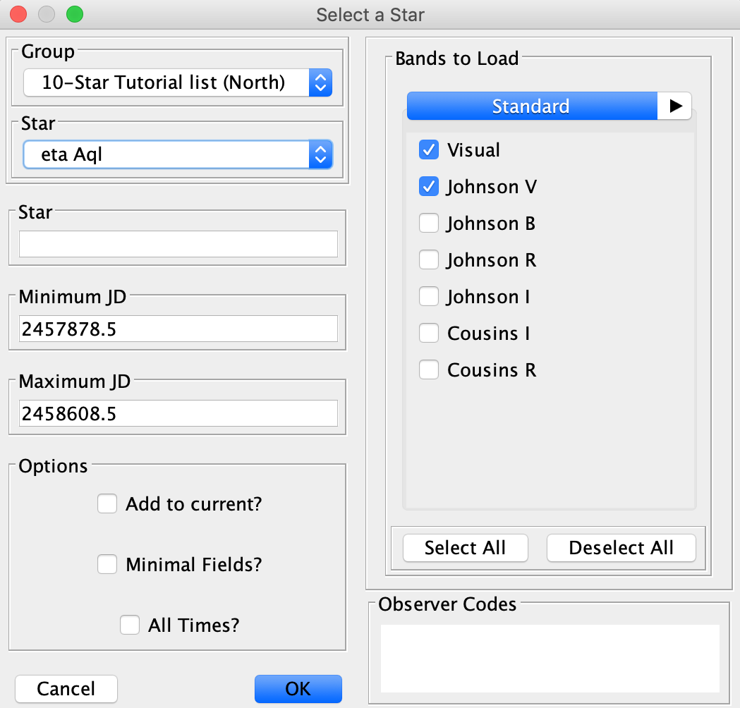
If a name or AAVSO Unique ID (AUID) of a variable star is entered into the Star text box, this will be used instead of the currently selected object in the Group section's Star drop-down. The “10-Star Tutorial list (North)” contains all stars from the “10 star” tutorial document. The “11-Star Tutorial list (South)” contains all stars from the “Southern Gems” tutorial document. Other groups can be created via the Preferences dialog.

If the Add to current? checkbox is selected, observations loaded from AID will be added to those already loaded into VStar. See the Additive Loads section below for further details.

Either a Julian Date range must be specified or All Times? selected. This determines the time range over which data should be loaded.

If the Minimal Fields? checkbox is selected, a minimal set of fields for each observation is loaded to reduce load time.

By default, Visual and Johnson V bands are selected for download, but more can be specified.

Space-delimited observer codes can optionally be specified to further reduce the number of observations loaded.

If the requested object does not exist or there is no data for the object in AID or for the specified date range, a message box will appear to that effect, otherwise the available data will be loaded, the light curve plot, observation list, and mean series created. If visual or V band data exists, corresponding observations will be initially visible; this can subsequently be changed via the Plot Control Dialog (see View menu). Otherwise, the band with the most observations will be displayed initially.

Load from File
To load observations from an AAVSO download format file or “simple” file, select the New Star from File... menu item from the File menu or click the second-to-left-most button in the toolbar.

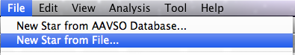

Files must conform to one of two formats:

- AAVSO download format
  - http://www.aavso.org/data-download
  - http://www.aavso.org/format-data-file

- Simple format, consisting of lines of the form:

Julian Date,Magnitude,[Uncertainty],[Observer Code],[Validation Flag]
or simply:
Julian Date,Magnitude

In both cases (AAVSO download and simple formats), lines can either be comma or tab separated. For the simple format, a space may instead be used as a delimiter. Notice that delimiters must be retained for optional values, e.g. in the following simple file example, uncertainty and validation flag are omitted:

2456423.123,4.2,,BDJB,

Comments may be used in simple format and AAVSO files by starting a line with a “#” character. Everything else on that line will be ignored.

Magnitude values may be prefixed by negative signs, e.g. -4.2.

Lines starting with “#” are considered to be comments, except for a line of the form:

#NAME=SomeObject

If present, this directive will lead to “SomeObject” being displayed in the plot title. Whereas the AAVSO download and some other formats contain object name information, the simple format does not. This directive overcomes that shortcoming and can also be used with AAVSO download format files.

Observations of other kinds can be loaded via observation source plug-ins. See the AAVSO plug-in library for more.

Selecting the New Star from File... menu item invokes the following file chooser:

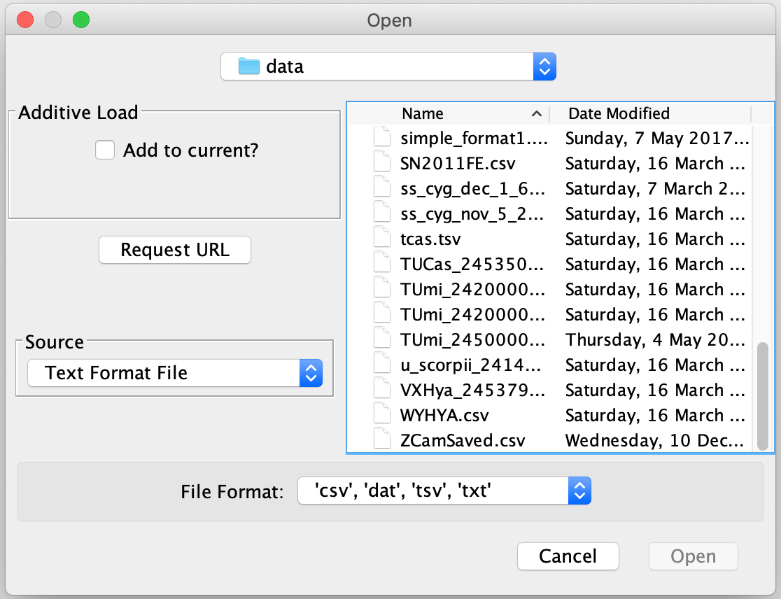
Choosing a conformant file and clicking the Open button will load the observations, leading to the same result as a Load from AID operation. If the file is not of a suitable format, an error dialog will be displayed.

Some observation source plug-ins accept a URL (Uniform Resource Locator or web page address) instead of a file to read observations from. In such cases, the dialog will have a Request URL button as shown above and as follows:

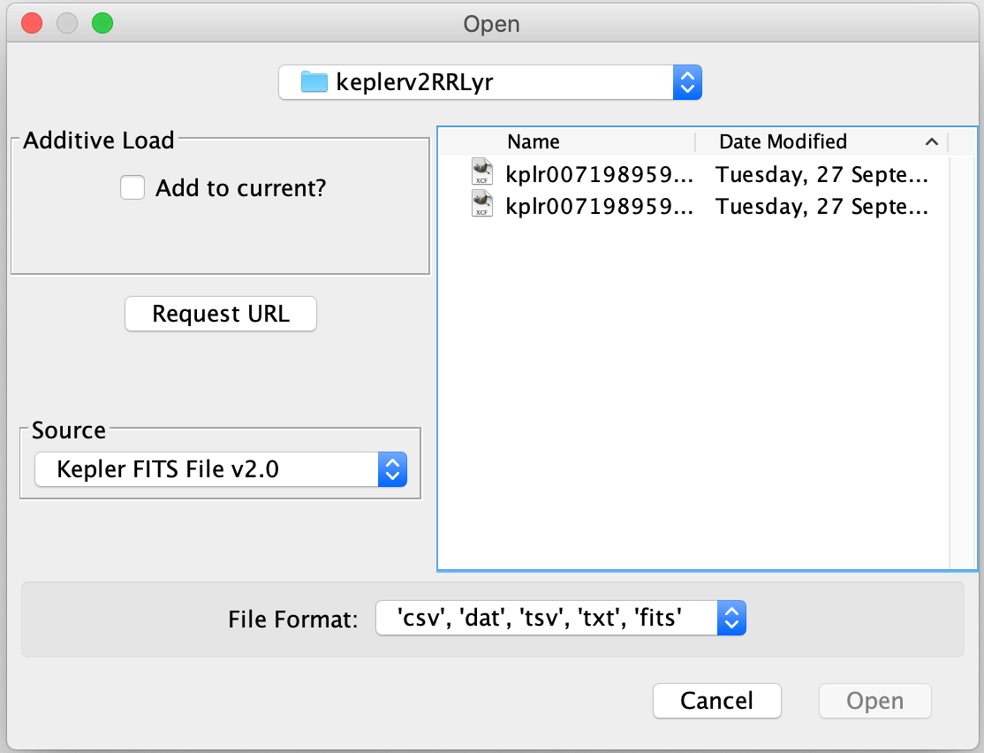

Selecting the button will yield this dialog:

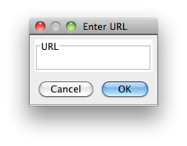

Some observation source plug-ins may only accept a URL as input in which case the following form of the Enter URL dialog will be presented to the user.
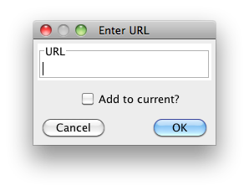

For example, the URL for an AAVSO download format file can be obtained by copying the first link (e.g. right mouse button click on Windows or control-click on Mac) on the “Your Data Request Has Been Filled” page that results from completing the download form, e.g.

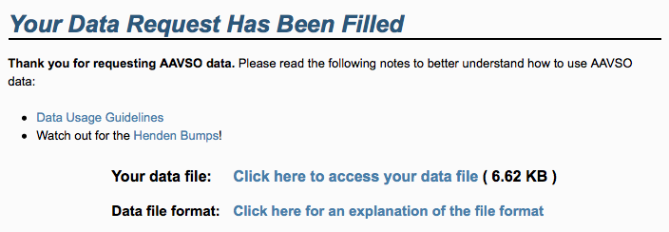

For AAVSO download format requests, it may be simpler to download the file to your computer and open it normally via the file chooser. For some other observation source plug-ins, such as the one for ASAS observations, use of a URL may seem more natural. See also the Plug-ins section.

The second file dialog above also shows that observation source plug-ins may handle additional file extensions (e.g. “.fits”), aiding in file list filtering in the file chooser.

Additive Loads
If the Add to current? checkbox is selected in any observation source dialog, the loaded observations will be added to any already loaded, irrespective the object. In this way, observations from different sources can be combined in a single VStar session.

If the newly loaded observations use Heliocentric Julian Dates (HJD), the previously loaded observations will be converted to use HJD or vice versa. If the first data set is loaded from the AID, the object’s Right Ascension (RA) and Declination (Dec) are taken from VSX (J2000.0 epoch). In other cases, dialogs permit the entry of RA and Dec for non-AID loads, such as the following:

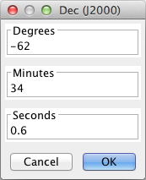
If successful HJD conversion takes place for a given additive load, a dialog will inform the user of this.

